Required Components in Support of Self-Evaluation

Organization of Self-Evaluation Process
During the past six years, Mt. San Jacinto College has been actively engaged in various Accreditation activities, including completion of Follow-Up, Midterm, and Annual Reports as well as Commission trainings. As such, planning for Accreditation has become integrated into the College’s culture, organizational structure, and institutional processes, making it possible to seamlessly commence the planning structure for the 2018 Accreditation Institutional Self-Evaluation Report.
Planning for the 2018 Accreditation Institutional Self-Evaluation Report began in spring 2016. Two representatives from the Commission, Vice Presidents Dr. Norv Wellsby and Jack Pond, provided a day-long training on April 1, 2016 at Bakersfield College to a number of community colleges with upcoming site visits. The training provided an overview of the purposes of Accreditation, a summary of the new Accreditation Standards, components of the Institutional Self-Evaluation Report and Site Visit, as well as information related to institution-set standards, institutional data, and evidence requirements.
Mt. San Jacinto College sent a team of nine individuals representing all constituent groups (faculty, classified, and administration) and institutional divisions (Instruction, Student Services, and Administrative Units) to the Commission hosted training. The team members were identified through a collaborative discussion between Academic Senate leadership and Administration and included the following:
- Rebecca Teague – Dean, Institutional Effectiveness, Planning, Research and Grants / Accreditation Liaison Officer
- Ted Blake – Learning Center Coordinator / Faculty Accreditation Liaison Officer
- Dr. Jeremy Brown – Instructional Dean – Arts and Humanities Menifee Valley Campus
- Martha Crawford – Student Success and Support (SSSP) Director
- Kristen Grimes – Executive Assistant to the Superintendent/President
- Paul Hert – Institutional Assessment and Program Review Coordinator (Faculty)
- Brandon Moore – Executive Dean, Institutional Effectiveness, Assessment, and Student Success
- Jeannine Stokes – Associate Dean, Human Resources
- Julie Venable – Dean, Administrative Services/Controller
The College used this team, later identified as the “Bakersfield 9 or B9” to design the organizational structure of the Self-Evaluation process and act as part of the institutional accreditation leadership over the subsequent two years leading up to the site visit. This team worked together with the ALO and Faculty ALO to:
- Develop a timeline for completing the Institutional Self-Evaluation Report
- Define organizational and oversight structure (Accreditation Steering Committee)
- Recommend faculty, classified, and administrators to participate on the Accreditation Steering Committee and Standard Workgroups
- Design Accreditation training presentations
- Develop an Accreditation “Fanny Pack” with useful materials, resources, and guides
- Create an Accreditation Standard Writing Template
- Identify methods for communicating issues related to Accreditation
- Establish a website to act as the central comprehensive clearinghouse for all Accreditation and planning resources
Accreditation Steering Committee and Standard Workgroup Structure and Responsibilities
In late spring 2016, the ALO and Faculty ALO worked with the Academic Senate, Classified Senate, and Student Government Association (SGA) leadership to do a call-out for participation on the College’s Accreditation efforts. An Accreditation Steering Committee and Accreditation Standard Workgroups were established. The Accreditation Steering Committee acted as the oversight committee with chair representatives from each of the Standard Workgroups as well as resource and support staff. The Accreditation Steering Committee was chaired by the Superintendent/President, the ALO, and the Faculty ALO.
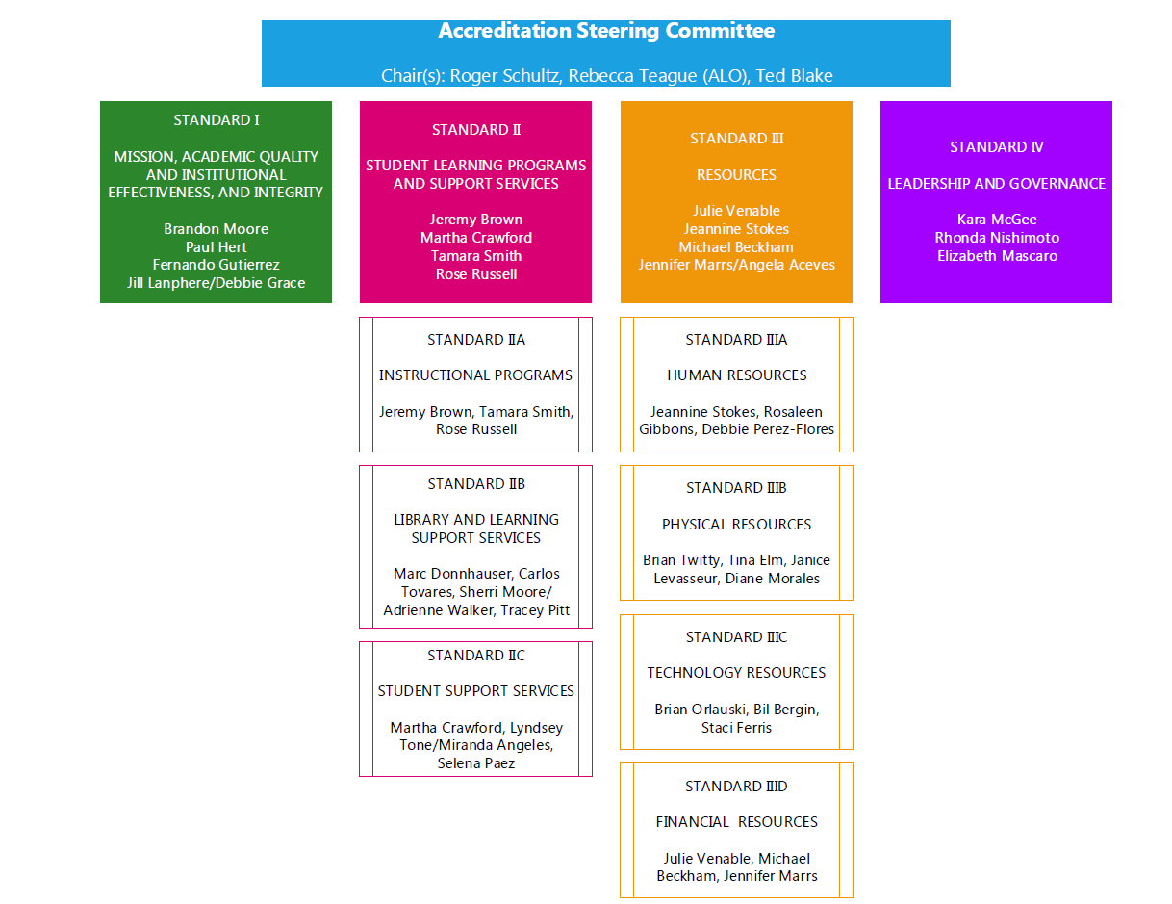
The primary role of the Accreditation Standard Workgroups was to provide draft bullet summaries as well as document evidence for each Accreditation Standards. The College had a total of nine (9) Standard Workgroups including Standard I, Standard IIA, Standard IIB, Standard, IIC, Standard IIIA, Standard IIIB, Standard IIIC, Standard IIID, and Standard IV. Each Standard Workgroup was led by a tri-chair structure between a faculty member, classified staff, and administrator. The Workgroups represented a diverse collection of individuals from all areas of the institution to ensure there were wide-ranging perspectives related to each Standard and that the groups were not working in a silo-environment.
ACCREDITATION STANDARD | WORKGROUP MEMBERS
STANDARD I | Chairs: Brandon Moore, Paul Hert, Fernando Gutierrez  Gloria Sanchez, Richard Sisk, Stacey Searl-Chapin, Tim Lampley, Debbie Grace, Jill Lanphere
STANDARD II
STANDARD IIA | Chairs: Jeremy Brown, Martha Crawford, Tamara Smith  Michelle Stewart, Roy Ramon, Nick Reeves, Eric Ozolins, Janet McCurdy, Angela Seavey, Tina Vandewater, Beatrice Aguilar, Jamie Marrs, Rose Russell, Joyce Johnson, Kristi DiMemmo, Pam Wright, Teri Safranek, Amy Campbell
STANDARD IIB | Chairs: Micah Orloff, Sherri Moore, Adrienne Walker, Tracey Pitt  Herb Alarcon, Luis Mondragon, Evelyn Menz, Annie Schaadt, Andrea Hammock, Lorrie Ross, Becki Ames, SI Staff (Janice Levasseur), Carrie Stantz, Carlos Tovares
STANDARD IIC | Chairs: Martha Crawford, Lynsey Tone, Miranda Angeles, Selena Paez  Heather Pomerenke, Shartelle Fears, April Vrtis, Tatiana Somers, Susie Hochstrat, Jenn Burleson, Belen Farinas, Meredith Goebel, Angela Barbera, Elizabeth Mascaro, Maya Cardenas, Faith Nobles, Dolores Smith, Susan Loomis, Tom Spillman, Terri Russell, DSPS Representative
STANDARD III
STANDARD IIIA | Chairs: Jeannine Stokes, Rosaleen Gibbons, Debbie Perez – Flores  Sterling Roulette, Karen Cranney, Lauren Springer, Christopher Kiser, Lanell Covington-James, Mary Scott, Dean of Math/Science
STANDARD IIIB | Chairs: Brian Twitty, Janice Levasseur, Diane Morales  Tina Elm, Dave Brunken, Gina Oliver, Daryl Wilkes, Carole Ward, Venita Durgin, Tammy Cunningham
STANDARD IIIC | Chairs: Brian Orlauski, Bil Bergin, Staci Ferris  Del Helms, Damien Greathouse, Katherine Stratton, Aaron Stafford, Justin Bennett, Jared Davis, Mike Palacios, Micah Orloff, Anna Stirling
STANDARD IIID | Chairs: Julie Venable, --------, Jennifer Marrs  Ron Bowman, Michael Weldon, Jennifer Pickens, Angela Aceves, Stacy Kimbrough, Elaine McCallum, Brenda Medina, Gail Jensen
STANDARD IV | Chairs: Kara McGee, Rhonda Nishimoto, Elizabeth Mascaro  Christina Yamanaka, Karla Maroudas, Morgan Hoodenpyle, Marcus Castellanos, Kristen Grimes, Kathy Donnell, Rebecca Orlauski

Once membership for all of the committee and workgroup structures had been identified, the College held an Accreditation Kick-Off with the Chairs of the nine Standard Workgroups (Accreditation Steering Committee) as well as key resource and support staff. The Accreditation Kick-Off was held on June 9, 2016 to formally start the Institutional Self-Evaluation Report process. The attendees received a comprehensive orientation to the Self-Evaluation process, including the tentative timeline, overview of Accreditation, the Accreditation Standards, and components of the Institutional Self-Evaluation Report (including eligibility requirements, evidence, quality focus essay, etc.), committee roles and responsibilities, and templates for developing the Standard drafts, as well as support materials, resources, and guides. Documents including past Accreditation reports were also included as resources, and provided to each committee member electronically.
The Accreditation Steering Committee has met on a consistent monthly basis since fall 2016 to provide updates regarding progress relative to the drafting of each Standard and evidence collection. Agendas and minutes of the Accreditation Steering Committee are posted on the Accreditation website to keep the College apprised of Accreditation-related updates.
The Standard Workgroups began working after the June 9, 2016 Accreditation Kick-Off on the Standard templates. Most workgroups predominantly met in the summer 2016 and fall 2016 to discuss and draft bullet summaries for each of the Standard criteria identified in the ACCJC’s Guide to Improving and Evaluating Institutions. The ALO and Faculty ALO met with the Standard Workgroups frequently to ensure that the Workgroups were adhering to the timelines and summary templates. Bullet summary drafts for each Standard were completed by the Workgroups throughout fall 2016 and spring 2017.
During the spring, summer, and fall 2017, the Workgroups worked to collect and identify evidence through each of the Standards. An evidence inventory was developed and used to catalog and collect all evidence used within the Institutional Self-Evaluation Report.
As drafts were completed by the Standard Workgroups, the ALO and Faculty ALO assumed the roles of writers and content editors. As full drafts were completed by the ALO and Faculty ALO, they were distributed to the Standard Workgroups, the Accreditation Steering Committee, Academic Senate and the College’s Board of Trustees. Given that the Institutional Self-Evaluation Report is an extremely complex document, it was important to the College that all groups had opportunities to review and provide feedback one Accreditation Standard at a time versus waiting until an entire draft of the Institutional Self-Evaluation Report was completed. The drafts were made available to the College community via the College website for review, discussion, and feedback.
Over the course of the two years the College developed the Institutional Self-Evaluation Report, the College underwent an extensive and in-depth period of self-reflection. The Quality Focus Essay (QFE) grew out of not only the comprehensive self-evaluation necessary for accreditation purposes but also from the College’s strategic and educational master planning efforts that established short- and long-term institutional priorities for the future. The College held an all-faculty meeting in October 2016 and several Educational Master and Strategic planning retreats in fall 2016 and spring 2017. Guided by these two simultaneous examination activities, the College identified two areas of improvement for the Quality Focus Essay. The College’s Quality Focus Essay was fully vetted by the Academic Senate, faculty, administrative leadership, and staff during fall 2017.
Each of the Standard drafts were completed by September 2017. Drafts of the full Institutional-Self Evaluation Report were completed in October 2017 and presented to the Academic Senate, Classified Senate, Student Government Association, and the Board of Trustees for information, review, and formal approval.
Throughout the development of the Institutional Self-Evaluation Report, the ALO and Faculty ALO made numerous presentations regarding the drafts, accreditation updates, and evidence collection to faculty, classified, students, administrators, and the Board of Trustees.
Institutional Self-Evaluation Report Timeline
Spring 2016 (April-June)

- ACCJC Self Evaluation Team Training
- Bakersfield 9 Team Retreats – Review all Accreditation publications related to Eligibility Requirements, Accreditation Standards, and Commission Policies
- Develop Steering Committee and Self-Evaluation Organizational Structure (Roles/Responsibilities of groups/Committees participating in the process)
- Develop MSJC Accreditation Timeline
- Kick-off Steering Committee Meeting
  - Recruit and Identify Standard Group Chairs/Members
  - Train Steering Committee Members
  - Schedule Monthly Steering Committee Meetings
- Provide updates to shared governance committees, Academic Senate, Classified Senate, SGA

Summer 2016 (June-August)

- Develop Evidence Collection practices for Self-Evaluation
- ALO/Faculty Chair draft outlines for the Self-Evaluation Report (Including introductory sections)
- Design Self-Evaluation website and repository
- Standard Workgroups meet and draft outlines
- Identify and Outline Data/Research for Self-Evaluation Report

Fall 2016 (Sept-December)

- Monthly Steering Committee and Standard Workgroup meetings
- Train Steering Committee members regarding Evidence Collection Practices for Self-Evaluation
- Standard Workgroups complete outlines
- Standard Workgroups develop and complete first draft
- Provide accreditation training and presentations to various constituent groups (Board, Faculty, Classified, Administration, Community)
Spring 2017 (January-May)

- Monthly Steering Committee and Standard Workgroup meetings
- Distribute 1st Draft to campus constituents for review/feedback
- Start Evidence Collection

Summer 2017 (June- September)

- Monthly Steering Committee and Standard Workgroup meetings
- Draft Quality Focus Essay
- Final Draft of Self-Evaluation Completed

Fall 2017 (September-December)

- Monthly Steering Committee and Standard Workgroup meetings
- Final Vetting/Approvals of Self-Evaluation Report to Academic Senate, Classified Senate, SGA, and Institutional Leadership
- Self-Evaluation Report – Information Item at BOT (November 2017)
- Self-Evaluation Report – Action Item at BOT (December 2017)

Spring 2018 (January-March)

- Mock Site Visit
- Monthly Steering Committee and Standard Workgroup meetings
- Site Visit Preparation/Training/Updates
- Submission of Self-Evaluation Report to Commission
- Site Visit
- Site Visit Debrief

EVIDENCE
- Accreditation Steering Committee Membership/Organizational Chart
- Accreditation Standard Workgroup Membership Chart
- Accreditation Steering Committee Meeting Agendas/Minutes
- Accreditation Website
- Accreditation Fanny Pack
- Accreditation Standard Templates
- Accreditation Evidence Inventory Instructions and Collection Sheet
- Accreditation Institutional Self-Evaluation Report Drafts
- Board of Trustees Agenda/Minutes
- Academic Senate Site Meeting Agenda/Minutes
- Academic Senate Executive Meeting Agenda/Minutes
- Classified Senate Agenda/Minutes
- Student Government Association Meeting Agenda/Minutes
- Accreditation Presentations
  - MSJC Accreditation Kick Off Meeting
  - Accreditation and the QFE
  - Accreditation Myths and Fears
  - Accreditation Board of Trustees Workshop
  - Accreditation Updates to Board of Trustees
  - Classified Professional Day
  - Convocation

List of Contracts with Third Party Providers and Non-Regionally Accredited Organizations
The complete list of Third-Party Providers for the 2016-2017 academic year is identified below.

Student Achievement Data
The Mt. San Jacinto College Institutional Research website includes detailed data, charts, and analyses for the following summation of student achievement data:
Institutional Data
- Service Area Data
  - Demographics (age, gender, ethnicity, socioeconomic status, disability status, educational attainment,
- Participation Rate Data
- Enrollment Trend Data
- Employment Trends

Student Achievement Data
Student achievement data should be in disaggregated form by:
- Age
- Gender
- Race/Ethnicity
- Socio-Economic status
- Delivery mode
- Instructional site
- Cohort group (look to program review, FYE, Veterans, DSPS, EOPS, Athletes, Calworks,etc)
- Other, as relevant to the institution’s service area and mission
Data on Incoming Students
- Student preparedness for college, including need for academic advising, assessment scores indicating need for remedial instruction and orientation, etc.
- Placement data (English, Math, ESL, Reading)
- Student training needs, including local employment training needs, transfer education needs, basic skills and/or ESL needs, etc.
- Student educational goals
Data on Enrolled students (when an institution reports rates in the following categories, it must specify the denominator)
- FT/PT student enrollment across the institution’s range of instructional programs
- Annual growth/decline in headcount enrollment (numbers or rates)
- Credit Student Unit Load distribution (Units per student)*
- Enrollment status (First-time student, returning, continuing, special admit/other *)
- Educational Goals (transfer, degree/certificate, career development, other educational goal, undecided)*
- Credit/Noncredit section offerings*
- Section offerings and enrollments by location*
- Course completion (numbers or rates)
- Student success
- Retention
- Persistence of students from term to term (numbers or rates)
- Student progression to the next course in a sequence of courses/next level of course (numbers or rates)
- Student program completion (numbers or rates)
- Certificate/degree completion (numbers or rates)
- Student transfer to four-year institutions (numbers or rates)
The data should be provided separately for the following credit/non-credit programs:
- Liberal Arts or Liberal Education/Transfer Programs
- Career and Technical Education (CTE) Programs
- Basic Skills and English as a Second Language (ESL) Programs
Data on Graduates
- Student job placement (number or rates) as appropriate
- Licensure/certification exam (numbers or rates) as appropriate
Other required evidence related to student achievement
- Policies and procedures for award of credit, including application of the credit hour definition in the Commission’s “Policy on Institutional Degrees and Credits”
- Policies and procedures for transfer of credit, including examples of the decision-making process
- Comprehensive list of agreements with other institutions on transfer of credit
Institution Set Standards/IEPI Indicators
Location/College Sites

