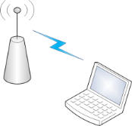**Campus Wireless Access**

**August 10, 2011**

**Overview**

Mt. San Jacinto College has wireless access on the Menifee and San Jacinto campuses. All you need to connect is you’re wireless computer, my.msjc.edu login and password.

**FAQ**

* **Where can I connect?**  
  Wireless access points are currently available the both campus’s cafeteria and libraries, and the Menifee Technology Building. Below is a visual representation of the hotspots on both campuses marked in green.
  + 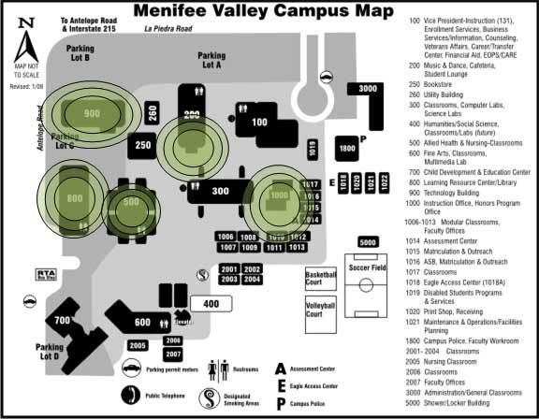Menifee Campus
  + San Jacinto Campus



**How do I connect to the wireless network?**  
You’re wireless computer should find the network labeled ‘MSJC_Student_Wireless’. Connect to that network. Once connected, open any web page, such as [http://www.msjc.edu](https://www.msjc.edu/), to be prompted for access with your my.msjc.edu username and password.  
