Windows Remote Desktop Services allows to remotely connecting to the district and run Outlook, access files, and running other needed applications from home or afar.

How to connect to the remote access system:
- Go to http://remote.msjc.edu
- Login with your district active directory (AD) username and password
Username is entered MSJCAD\username to include our AD domain. (For example MSJCAD\user)
See Figure 1
- Click on the “Remote Desktop” icon
See Figure 2
- Login with your district active directory (AD) username and password
Username is entered MSJCAD\username to include our AD domain. (For example MSJCAD\user)
See Figure 3

Requirements:
Windows XP, Windows Vista, or Windows 7
Current Windows Patches and Service Packs
Current Virus and Spyware Protection
Internet Explorer web-browser (7.x or higher) and internet connection (Other browsers will not work)

What programs are available on this system?:
Access to your network drives
Datatel 2.3
Eureka
Galaxy (No Report Printing Available)
Hershey Systems
Office 2010 Suite and Applications
Remote Desktop (to connect to your desktop computer)
SARS·GRID

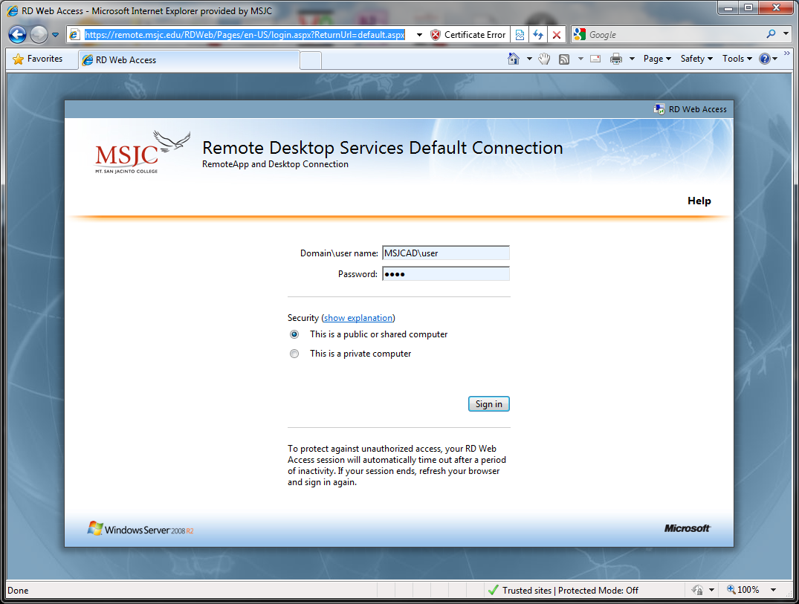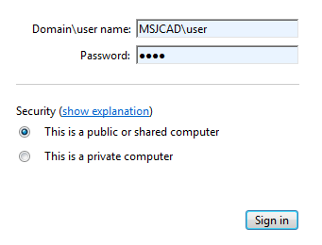
Figure 1 - http://remote.msjc.edu – Remote Desktop Web Login
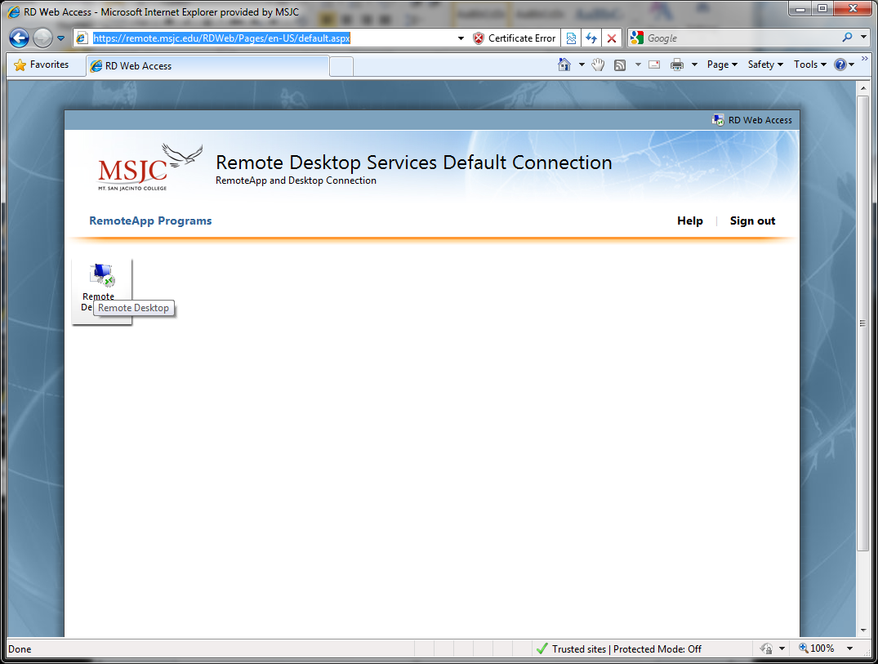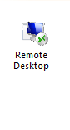
Figure 2 - http://remote.msjc.edu – Remote Desktop Link
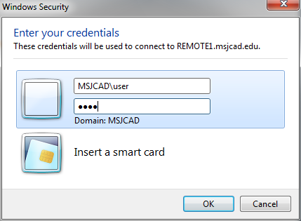
Figure 3 - http://remote.msjc.edu – Connection Login Prompt

Troubleshooting:
Listed are a couple of the common issues and solutions.
Issue: | You may be prompted to run the Remote Desktop Services ActiveX Client control. How do I do that?  This webpage wants to run the following add-on: ‘Microsoft Remote Desktop Services Web Access Con…’ from ‘ Microsoft Corporation’.  Figure 1 - ActiveX Client control Error in Internet Explorer 8  or  Figure 2 - ActiveX Client control Error in Internet Explorer 9
Solution: | We have found that this dialog may appear the first time you http://remote.msjc.edu.  If you are prompted to run the Remote Desktop Services ActiveX Client control when you access http://remote.msjc.edu, do one of the following, depending on your operating system:  If you are running Windows Server 2003 or Windows XP, and you are prompted to run the Remote Desktop Services ActiveX Client control, click the message line, click Run ActiveX Control, and then click Run. After you have enabled the control, refresh the Web page.  Figure 3 - Internet Explorer 8 ActiveX Warning  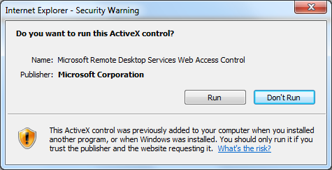  Figure 4 - Internet Explorer 8 ActiveX Warning  If you are running Windows Server 2008 or Windows Vista, click the warning message on the Internet Explorer Information bar, point to Add-on Disabled, and then click Run ActiveX Control. When you do this, you might see a security warning. Make sure that the publisher of the ActiveX control is "Microsoft Corporation" before you click Run.  If you are running Windows Server 2008 R2 or Windows 7, in addition to the above steps, you can choose to allow the ActiveX control to run only on this website.  Figure 5 - Internet Explorer 9 ActiveX Warning – Allow Buton  If the Internet Explorer Information bar doesn't appear, you can enable the ActiveX control by using the Manage Add-ons tool on the Tools menu of Internet Explorer.  Reference: http://technet.microsoft.com/en-us/library/ff608246(WS.10).aspx

Issue: | You may receive the following error while connecting to http://remote.msjc.edu:  RD Web Access requires JScript. This Web browser either does not support JScript, or scripts are being blocked.  To find out whether your browser supports JScript, or to allow scripts, see the browser's online Help.  Figure 6 - Internet Explorer 9 JScript Disabled Error
Solution: | We have found that this error can be related to Jscript being disabled or one of the following sites as being a Restricted Site: remote.msjc.edu, *.msjc.edu  Add *.msjc.edu as a Trusted Site in Internet Explorer:  - Click the Tools button, and then click Internet Options.  - Click the Security tab, and then click a security zone Trusted sites, and Click Sites.  - Type *.msjc.edu in the Add this website to the zone field and Click Add.  If the check box for Require server verification is checked,  Clear the Require server verification (https:) for all sites in this zone check box.  - Click Close, and then click OK (or click OK twice if you clicked Local intranet in step 4).  Figure 7 - Adding remote.msjc.edu to Trusted sites  Reference: http://windows.microsoft.com/en-US/windows7/Security-zones-adding-or-removing-websites

Issue: | You may receive the following error upon connection to remote.msjc.edu via the Remote Desktop Connection:  The identity of the remote computer cannot be verified. Do you want to connect anyway?  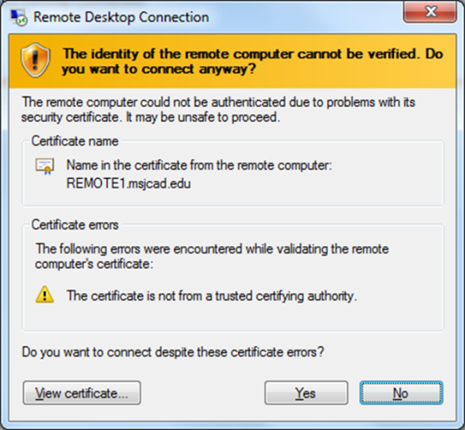  Figure 8 - Remote Desktop Connection Certificate Error Dialog
Solution: | We currently have a self-signed certificate (not created by an outside source – such as Verisign) to encrypt Remote Desktop Connection traffic. You must accept the errors in order to connect (Click Yes.) We anticipate adding a Trusted Certificate.  Reference: http://support.microsoft.com/kb/2000960

Issue: | You may not have access to a computer with the required Operating System, Internet Browser, or other limiting factor.
Solution: | Contact our department to be given specific information or remedy. We can assist with connecting via Linux, Macintosh computers, or other clients on request.  Our contact information is maintained on the following web page:  http://www.msjc.edu/IT/Pages/helpdesk.aspx

